Subduction Zone Volcanoes

A Subduction Zone volcano is just that - a volcano which occurs near a subduction zone.
What is happening is this - the subducting plate is being forced under the other, "stationary" plate. In the process, a large amount of friction is going on, the plates are rubbing together, and the subducting plate forces its way through the upper parts of the mantle. Since the rock that forms the Earth's crust melts at a relatively low temperature, and it is entering into the hot mantle, magma is being formed. Being that molten rock is less dense than that of the solid variety, this once-crust liquid rock begins pushing up through cracks, crevices, holes and whatnot through the crust. Often it will form in reservoirs near the top of the crust.
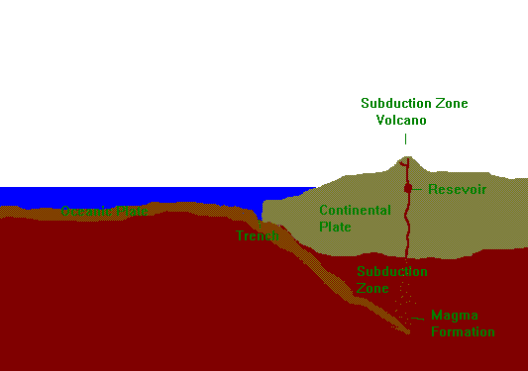
So, you should now be asking, how does this support the theory of plate tectonics? First of all, if you look at a map of the Pacific Ocean, where one can find the most subduction zones and volcanoes, you can see that volcanoes only show up "behind" ocean trenches that mark the subduction zone - right about where the subducting plate would be melting, and the magma rising to create volcanic activity. When one looks at a map showing plates and volcanoes, one can hardly fail to see that there is a clear relationship between subduction zones and volcanoes.

Here's another piece of evidence. On the floor of the ocean, on top of the plates, is a layer of sedimentary rock - the result of silt from rivers, erosion, and other natural processes. Well, this sedimentary stuff shows up a lot in magma around subduction zones in the Pacific - in Andesite, which contains more sedimentary materials than its two "brother" magmas, Ryholite and Basalt. This sedimentary layer sinks with its accompanying plate and forms magma in the mantle, just as the rest of the plate does. The sedimentary material mixes with the basaltic mantle, and andesitic magma is formed.

Ryholitic and andesitic lava (magma, once it reaches the surface) is most often associated with subduction zone volcanoes (basaltic, the other variety, is usually related to hot spot volcanoes You've already seen how andesitic magma is formed, now you'll learn how ryholitic is. Ryholite contains a lot of granite. Granitic rocks are the primary types that make up the continental crust. Thus, when an upwelling of hot magma makes contact with the bottom of a continental plate, granite composing the continental plate melts and becomes part of the lava. This is the primary way (in relation to subduction zone volcanoes) in which ryholitic magma is formed. As you may notice, this also lends support to the theory of plate tectonics.

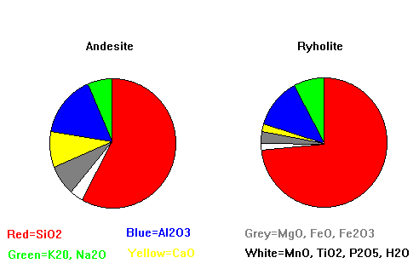
This is a chart of the chemical composition of ryholitic and andesitic magma.

Once this magma reaches the surface, it cools and hardens to form rock. Eventually, this process builds a large, uprisen mountain around the vent from whence the magma found its way to the air. However, volcanic structure and external features offer almost no support to the theory of plate tectonics, so it will be mentioned only in this brief paragraph to close all the explanations about magma and subduction zones.

Well, I hope that you have learned something by viewing this page, and I hope it held your interest. More importantly, I hope you have become a believer (or a firmer believer) in the great theory of plate tectonics.

Use an ACE Response for the following question:
What evidence is provided for the tectonic plates, and how does that evidence support the theory of tectonic plates?

