Weather Map Symbols: Wind Barbs

The symbol below is of a wind barb. Wind barbs contain a lot of information including wind speed and direction.
Temperature: The 64 indicates the temperature in Fahrenheit.
Dew Point: The 58 indicates the Dew Point (the air becomes saturated at this temperature).
Air Pressure: The 027 indicates the last three digits of the air pressure in millibars.
Less Than 500: Add 10 to the front of it and divide by 10. For example 027 becomes 1002.7 mb.
Greater Than 500: Place a 9 on the front of it and divide by 10. For example 678 becomes 967.8 mb.

Cloud Cover: The center of the Barb indicates cloud cover. See the figure to the right
- Clear: Covers less than 1/10th of the sky.
- Scattered Clouds: Covers between 1/10th to ½ of the sky.
- Broken Clouds: Covers between ½ to 9/10th of the sky.
- Overcast: Covers more than 9/10th of the sky.
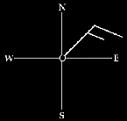
Wind Direction: The barb is pointing toward the direction from which the wind blows. In this example the wind is from the Northeast. Winds are always named by the direction they come from, not the direction they are heading.

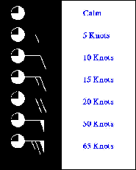
Wind Speed: Wind speed is indicated in Knots per hour (kph). A Knot is a nautical mile per hour.

1 Knot = 1.15 miles per hour

1 Knot = 1.9 km per hour

Short Barbs: Each short barb is 5 Knots
Long Barbs: Each long barb is 10 Knots

Pennants: Each pennant is 50 Knots

To get the wind speed simply add the barbs up. For the 65 Knot wind it is (50 + 10 + 5). If there is no barbs the wind is calm.

: Wind Barbs
Interpreting Surface Observation Symbols
scaffolding activity
Purpose:
The purpose of this activity is to introduce these reporting symbols and how to extract information about temperature, dew point temperature, wind speed and direction, cloud cover, pressure, the most common weather symbols, current weather, and how to interpret current weather conditions for cities on a map of surface observations.

Introduction:
Routine surface meteorological observations are represented on weather maps by a standard notation of symbols and numbers. In order to correctly interpret the data, it is important to understand what types of data the different numbers and symbols represent. This skill is not only important for reporting weather conditions for a given station, but also for determining the positions of significant meteorological features like fronts, cyclones and anticyclones.
Components of the Observation Symbol:
1) Fill in the blanks of the diagram to indicate what type of meteorological data is represented by each location.
- _______________________

- _________________________

- _________________________

- _________________________

- _________________________

- _________________________
Reporting on Weather Conditions:
Use the map of surface observations on the next page to answer the following questions.

- What is the temperature in Des Moines, Iowa?
3) What is the dew point temperature in Phoenix, Arizona?
4) What is the pressure in Dallas, Texas?
5) What is the report of cloud cover in Chicago, Illinois?
6) What is the weather symbol for Casper, Wyoming?
7) What is the speed and direction of the wind in Miami, Florida?
Reporting Current Weather Conditions:
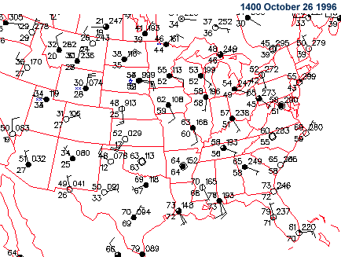
- Now apply what you have learned to real-time weather data. Using the map on the projector for the Salisbury station or http://weather.cod.edu/wx/public/sfc/states/md.sfc.gif and copy the symbol below. Now list the latest observations for temperature, dew point temperature, cloud cover, pressure, current weather, wind direction and wind speed.
- Temperature
- Dew Point Temperature
- Cloud Cover
- Pressure
- Current Weather
- Wind Direction
- Wind Speed

Interpreting Weather Symbols:
In addition to temperature, dew point temperature, cloud cover, pressure and wind observations, a surface observation symbol also reports the current weather through the weather symbol. Conditions for clear skies, rain, snow and fog have appropriate symbols which are displayed as needed for each station report. The chart to the right indicates the common weather symbols:

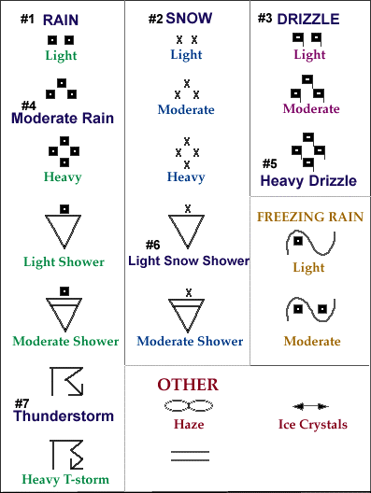
Reporting Weather Conditions:
- Using the map on the front page of surface observations, and for each station that used a weather symbol in the station report, give the name of the city and the type of weather reported at that time. For each type of precipitation identified, indicate its intensity (whether its light, moderate or heavy). There are a total of 11 cities for which this data must be recorded.
City | Weather in Sample | Real Time Weather
a. Bismark, ND -- | Moderate Snow
- International Falls, MN —
- Salt Ste Marie, MI —
- Ottawa, Canada —
- Portland, ME —
- Detroit, MI —
- Chicago, IL —
- Huron, SD —
- St. Louis, MO —
- Atlanta, GA —
- Pensacola, FL —

- Now apply that knowledge to a real time map. Using the map on the projector or http://www.hpc.ncep.noaa.gov/sfc/90fbw.gif indicate the current weather in these same cities on the table above. If no symbol was given, then simply write “No Significant Weather”.
- Using the real time map or http://weather.cod.edu/wx/public/sfc/states/md.sfc.gif what is the weather in Salisbury, MD?

