Atmospheric Protocols - Notes
- Cloud Formation
  - Solubility of Water
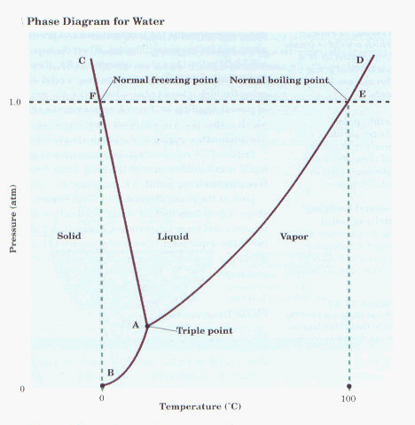
    - Basic facts of water.
      - States of Water: Water is known to exist in three different states; as a solid (ice), liquid (water) or gas (water vapor).
      - Freezing Point (FP) of water: = 0C or 32 F = Melting Point (MP)

      - Boiling Point (BP) of water = 100 C or 212 F = Condensation Point
    - Boiling point is defined as the temperature at which a substance boils at standard pressure (1.000 atmospheres, 760 mm of Hg, or 101.3 kPa).
    - Boiling point of any substance is when the vapor pressure equals the atmospheric pressure.
    - Vapor Pressure: The pressure that is due to the evaporation of a substance.
      - The vapor pressure increases with temperature.
      - This means that the higher the temperature the faster the rate of evaporation.
    - Energy changes with changes in state. If a plot of data points were made of a pot of ice at -15 C being heated to 125 C it would look like this:
    - The flat areas of the graph are where the changes of state occur.
      - It takes energy to change the states of water.
      - This means that at 0 C there can be both ice and water.
      - This is why when people sweat they feel cooler. The water that is evaporating to form water vapor is absorbing heat.
  - Solubility: the ability of one substance to dissolve another and form a solution. This is normally temperature and pressure dependent. Solubility is described by the amount of the solute per amount of solvent at a particular temperature and pressure. This can be done in a variety of ways.
    - Solute: the smaller portion of the solution.
    - Solvent: the larger portion of the solution.
  - Factors of solubility of water in air.
    - Temperature: the higher the air temperature the more water that can be dissolved by the air. ↑T≈↑S Temperature is directly proportional to the solubility of water.
    - Pressure: the higher the air pressure the greater the more water that can be dissolved by the air. ↑P≈↑S Pressure is directly proportional to the solubility of water.
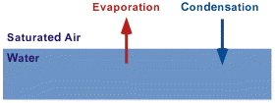
  - Condensation (clouds) occur when cooler objects (dust) pass through relatively warm, moist air.
    - Relative humidity may be defined as the ratio of the water vapor density (mass per unit volume) to the saturation water vapor density, usually expressed in percent:

    - Relative Humidity (RH) = (Actual Vapor Density) X 100%
          - (Saturation Vapor Density)

    - Actual water vapor is a measurement of moisture in the air and increases as the amount of water vapor increases. Air that attains its saturation vapor pressure has established an equilibrium with a flat surface of water. That means, an equal number of water molecules are evaporating from the surface of the water into the air as are condensing from the air back into the water.
    - Dew Point: the temperature to which the air would have to cool (at constant pressure and constant water vapor content) in order to reach saturation.
      - The saturation vapor pressure is a unique function of temperature as given below:
C Temp | F Temp | Saturated Vapor Pressure (mb) | C Temp | F Temp | Saturated Vapor Pressure (mb)
-18 | 0.0 | 1.5 | 18 | 65 | 21.0
-15 | 5 | 1.9 | 21 | 70 | 25.0
-12 | 10 | 2.4 | 24 | 75 | 29.6
-9 | 15 | 3.0 | 27 | 80 | 35.0
-7 | 20 | 3.7 | 29 | 85 | 41.0
-4 | 25 | 4.6 | 32 | 90 | 48.1
-1 | 30 | 5.6 | 35 | 95 | 56.2
2 | 35 | 6.9 | 38 | 100 | 65.6
4 | 40 | 8.4 | 41 | 105 | 76.2
7 | 45 | 10.2 | 43 | 110 | 87.8
10 | 50 | 12.3 | 46 | 115 | 101.4
13 | 55 | 14.8 | 49 | 120 | 116.8
16 | 60 | 17.7 | 52 | 125 | 134.2

    - For example, if the water vapor pressure in the air is 10.2 millibars (mb), dew will form when the ground reaches 45 degrees Fahrenheit (F). The relative humidity for air containing 10.2 mb of water vapor is simply 100% times 10.2 mb divided by the saturation vapor pressure at the actual temperature. For example, at 70 F the saturation vapor pressure is 25 mb, so the relative humidity would be
      - RH = 100% X (10.21 / 25.0) = 41%

- Formation of Clouds
- Rising Air: A key portion of Cloud Formation

- 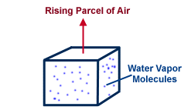
- Imagine a block of air, or air parcel, rising upward through the atmosphere. The air parcel expands as it rises and this expansion causes the temperature of the air parcel to decrease. As the parcel rises, its humidity increases until it reaches 100%. When this occurs, cloud droplets begin forming as the excess water vapor condenses on the largest aerosol particles. Above this point the cloud droplets grow by condensation in the rising air. If the cloud is sufficiently deep or long lived, precipitation will develop.
- 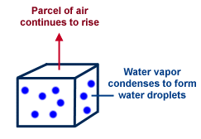
- Different Ways Air Rises
- Convection: In meteorology, convection refers primarily to atmospheric motions in the vertical direction.
- 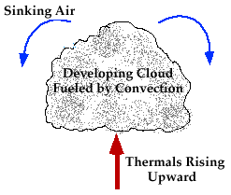
- As the earth is heated by the sun, bubbles of hot air (called thermals) rise upward from the warm surface. A thermal cools as it rises and becomes diluted as it mixes with the surrounding air, losing some of its buoyancy (its ability to rise). An air parcel will rise naturally if the air within the parcel is warmer than the surrounding air (like a hot air balloon). Therefore, if cool air is present aloft with warm air at lower levels, thermals can rise to great heights before losing their buoyancy. Successive thermals following the same path usually rise higher than previous ones, and if a thermal is able to rise high enough to cool to its saturation point, the moisture within condenses and becomes visible as a cloud.
- 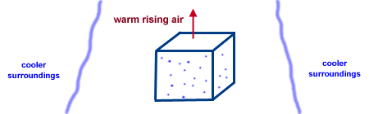

- When a deep stable layer exists just above the cloud base, continued vertical growth is restricted and only fair weather cumulus are able to form. However, if a deep unstable layer (cold air aloft) is present, continued vertical growth is likely, leading to the development of a cumulonimbus cloud, which contains raindrops. Once the supply of thermals is cut off, the cloud begins to dissipate and eventually disappears. Convective clouds are typically much more vertically developed than those clouds generated by convergence lifting.
- 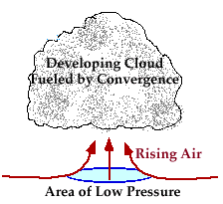

- Convergence:
- An atmospheric condition that exists when there is a horizontal net inflow of air into a region.

- When air converges along the earth's surface, it is forced to rise since it cannot go downward. Large scale convergence can lift a layer of air hundreds of kilometers across. Vertical motions associated with convergence are typically much weaker than the small-scale vertical motions associated with convective processes. As a result, clouds generated through convergence, for example cirrostratus clouds, are typically less vertically developed than convective clouds.
- Orography:
- 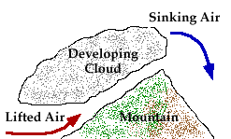
- When air is confronted by a mountain, it is lifted up and over the mountain, cooling as it rises. If the air cools to its saturation point, the water vapor condenses and a cloud forms. These types of clouds are called "orographic clouds", which develop in response to lifting forced by the topography the earth. The exact type of cloud that develops depends upon the moisture content and stability of the air.
- Fronts: Lifting also occurs along frontal boundaries, which separate air masses of different density.
- Cold Fronts: In the case of a cold front, a colder, denser air mass lifts the warm, moist air ahead of it. As the air rises, it cools and its moisture condenses to produce clouds and precipitation. Due to the steep slope of a cold front, vigorous rising motion is often produced, leading to the development of showers and occasionally severe thunderstorms.
- 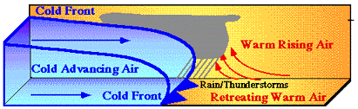
- Warm Fronts: In the case of a warm front, the warm, less dense air rises up and over the colder air ahead of the front. Again, the air cools as it rises and its moisture condenses to produce clouds and precipitation. Warm fronts have a gentler slope and generally move more slowly than cold fronts, so the rising motion along warm fronts is much more gradual. Precipitation that develops in advance of a surface warm front is typically steady and more widespread than precipitation associated with a cold front.
- 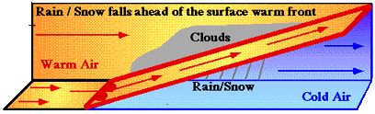
- 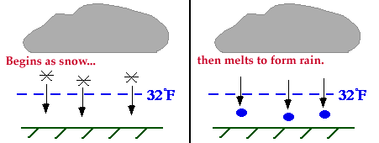

- Rain or Snow? Precipitation typically forms high in the atmosphere where the temperature is below freezing. As ice crystals form aloft and fall toward the surface, they collect each other to form large snowflakes. If ground temperature is above 32 F, the freezing level must be located somewhere above the ground. As the falling snow passes through the freezing level into the warmer air, the flakes melt and collapse into raindrops. During the summer months, it is not uncommon for the freezing level to be found at a level above cloud base.

- When the air temperature at the ground is less than 32 F, the snowflakes do not melt on the way down and therefore reach the ground as snow.
- 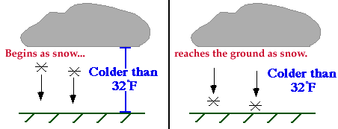

- Occasionally, we observe snow reaching the ground even though the outside temperature is above freezing. This occurs when a very thin layer of warm air is found near the surface. Since the layer of warm air is so shallow, the precipitation reaches the ground as snow before it has a chance to melt and become rain.
- 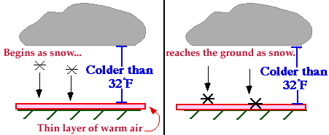
- Cloud Formation

- Solubility of Water
- Basic facts of water.
- States of Water: Water is known to exist in three different states; as a solid (ice), liquid (water) or gas (water vapor).
- Freezing Point (FP) of water: = 0C or 32 F = Melting Point (MP)

- Boiling Point (BP) of water = 100 C or 212 F = Condensation Point
- Boiling point is defined as the temperature at which a substance boils at standard pressure (1.000 atmospheres, 760 mm of Hg, or 101.3 kPa).
- 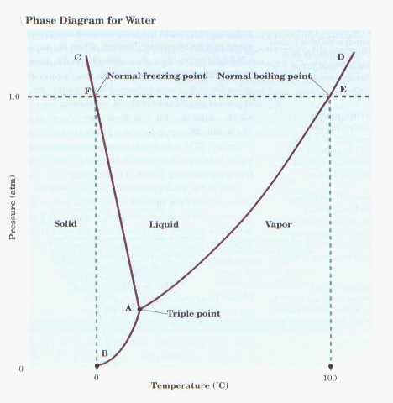
- Boiling point of any substance is when the vapor pressure equals the atmospheric pressure.
- Vapor Pressure: The pressure that is due to the evaporation of a substance.
- The vapor pressure increases with temperature.
- This means that the higher the temperature the faster the rate of evaporation.
  - Energy changes with changes in state. If a plot of data points were made of a pot of ice at -15 C being heated to 125 C it would look like this:
- The flat areas of the graph are where the changes of state occur.
- It takes energy to change the states of water.
- This means that at 0 C there can be both ice and water.
- This is why when people sweat they feel cooler. Heat is being absorbed by the water that is evaporating to form water vapor.
- Solubility: the ability of one substance to dissolve another and form a solution. This is normally temperature and pressure dependent. Solubility is described by the amount of the solute per amount of solvent at a particular temperature and pressure. This can be done in a variety of ways.
- Solute: the smaller portion of the solution.
- Solvent: the larger portion of the solution.
- Factors of solubility of water in air.
- Temperature: the higher the air temperature the more water that can be dissolved by the air. ↑T≈↑S Temperature is directly proportional to the solubility of water.
- Pressure: the higher the air pressure the greater the more water that can be dissolved by the air. ↑P≈↑S Pressure is directly proportional to the solubility of water.
- Condensation (clouds) occur when cooler objects (dust) pass through relatively warm, moist air.
- Relative humidity may be defined as the ratio of the water vapor density (mass per unit volume) to the saturation water vapor density, usually expressed in percent:

    - Relative Humidity (RH) = (Actual Vapor Density) X 100%
          - (Saturation Vapor Density)

- Actual water vapor is a measurement of moisture in the air and increases as the amount of water vapor increases. Air that attains its saturation vapor pressure has established an equilibrium with a flat surface of water. That means, an equal number of water molecules are evaporating from the surface of the water into the air as are condensing from the air back into the water.
- 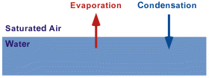
- Dew Point: the temperature to which the air would have to cool (at constant pressure and constant water vapor content) in order to reach saturation.
- The saturation vapor pressure is a unique function of temperature as given below:
C Temp | F Temp | Saturated Vapor Pressure (mb) | C Temp | F Temp | Saturated Vapor Pressure (mb)
-18 | 0.0 | 1.5 | 18 | 65 | 21.0
-15 | 5 | 1.9 | 21 | 70 | 25.0
-12 | 10 | 2.4 | 24 | 75 | 29.6
-9 | 15 | 3.0 | 27 | 80 | 35.0
-7 | 20 | 3.7 | 29 | 85 | 41.0
-4 | 25 | 4.6 | 32 | 90 | 48.1
-1 | 30 | 5.6 | 35 | 95 | 56.2
2 | 35 | 6.9 | 38 | 100 | 65.6
4 | 40 | 8.4 | 41 | 105 | 76.2
7 | 45 | 10.2 | 43 | 110 | 87.8
10 | 50 | 12.3 | 46 | 115 | 101.4
13 | 55 | 14.8 | 49 | 120 | 116.8
16 | 60 | 17.7 | 52 | 125 | 134.2

- For example, if the water vapor pressure in the air is 10.2 millibars (mb), dew will form when the ground reaches 45 degrees Fahrenheit (F). The relative humidity for air containing 10.2 mb of water vapor is simply 100% times 10.2 mb divided by the saturation vapor pressure at the actual temperature. For example, at 70 F the saturation vapor pressure is 25 mb, so the relative humidity would be
      - RH = 100% X (10.21 / 25.0) = 41%

- Formation of Clouds
- Rising Air: A key portion of Cloud Formation

- Imagine a block of air, or air parcel, rising upward through the atmosphere. The air parcel expands as it rises and this expansion causes the temperature of the air parcel to decrease. As the parcel rises, its humidity increases until it reaches 100%. When this occurs, cloud droplets begin forming as the excess water vapor condenses on the largest aerosol particles. Above this point the cloud droplets grow by condensation in the rising air. If the cloud is sufficiently deep or long lived, precipitation will develop.
- Different Ways Air Rises
- Convection: In meteorology, convection refers primarily to atmospheric motions in the vertical direction.
- As the earth is heated by the sun, bubbles of hot air (called thermals) rise upward from the warm surface. A thermal cools as it rises and becomes diluted as it mixes with the surrounding air, losing some of its buoyancy (its ability to rise). An air parcel will rise naturally if the air within the parcel is warmer than the surrounding air (like a hot air balloon). Therefore, if cool air is present aloft with warm air at lower levels, thermals can rise to great heights before losing their buoyancy. Successive thermals following the same path usually rise higher than previous ones, and if a thermal is able to rise high enough to cool to its saturation point, the moisture within condenses and becomes visible as a cloud.

- When a deep stable layer exists just above the cloud base, continued vertical growth is restricted and only fair weather cumulus are able to form. However, if a deep unstable layer (cold air aloft) is present, continued vertical growth is likely, leading to the development of a cumulonimbus cloud, which contains raindrops. Once the supply of thermals is cut off, the cloud begins to dissipate and eventually disappears. Convective clouds are typically much more vertically developed than those clouds generated by convergence lifting.

- Convergence:
- An atmospheric condition that exists when there is a horizontal net inflow of air into a region.

- When air converges along the earth's surface, it is forced to rise since it cannot go downward. Large scale convergence can lift a layer of air hundreds of kilometers across. Vertical motions associated with convergence are typically much weaker than the small-scale vertical motions associated with convective processes. As a result, clouds generated through convergence, for example cirrostratus clouds, are typically less vertically developed than convective clouds.
- Orography:
- When air is confronted by a mountain, it is lifted up and over the mountain, cooling as it rises. If the air cools to its saturation point, the water vapor condenses and a cloud forms. These types of clouds are called "orographic clouds", which develop in response to lifting forced by the topography the earth. The exact type of cloud that develops depends upon the moisture content and stability of the air.
- Fronts: Lifting also occurs along frontal boundaries, which separate air masses of different density.
- Cold Fronts: In the case of a cold front, a colder, denser air mass lifts the warm, moist air ahead of it. As the air rises, it cools and its moisture condenses to produce clouds and precipitation. Due to the steep slope of a cold front, vigorous rising motion is often produced, leading to the development of showers and occasionally severe thunderstorms.
- Warm Fronts: In the case of a warm front, the warm, less dense air rises up and over the colder air ahead of the front. Again, the air cools as it rises and its moisture condenses to produce clouds and precipitation. Warm fronts have a gentler slope and generally move more slowly than cold fronts, so the rising motion along warm fronts is much more gradual. Precipitation that develops in advance of a surface warm front is typically steady and more widespread than precipitation associated with a cold front.

- Rain or Snow? Precipitation typically forms high in the atmosphere where the temperature is below freezing. As ice crystals form aloft and fall toward the surface, they collect each other to form large snowflakes. If ground temperature is above 32 F, the freezing level must be located somewhere above the ground. As the falling snow passes through the freezing level into the warmer air, the flakes melt and collapse into raindrops. During the summer months, it is not uncommon for the freezing level to be found at a level above cloud base.

- When the air temperature at the ground is less than 32 F, the snowflakes do not melt on the way down and therefore reach the ground as snow.

- Occasionally, we observe snow reaching the ground even though the outside temperature is above freezing. This occurs when a very thin layer of warm air is found near the surface. Since the layer of warm air is so shallow, the precipitation reaches the ground as snow before it has a chance to melt and become rain.
- Cloud Types

- A cloud is a visible collection of tiny water droplets and/or ice crystals suspended in the atmosphere and can exist in a variety of shapes and sizes.

    - Naming Clouds - Latin Roots
  - Latin Root Translation Example
  - cumulus heap fair weather cumulus (puffy clouds)
  - stratus layer altostratus (flat strat)
  - cirro curl cirrus (high altitude)
  - nimbus rain cumulonimbus
  - alto high altocumulus Medium Height Cloud

    - Clouds are defined by two general areas:
- Altitude
              - High Clouds-Above 15,000 feet-Uses the prefix cirro.
              - Medium Clouds-Between 8,000 and 15,000 feet-Uses the prefix Alto-
              - Low Clouds-Up to 8,000 feet

- General Appearance
              - Cumulus-Puffy clouds
              - Stratus-Layer clouds
              - Nimbus-Rain clouds
            - They combine these two together to name the Cloud Types:
              - High Altitude Clouds:
- Cirrocumulus: high clouds with puffy, patchy appearance, with small spaces between clouds. Often form wave-like patterns.
- Cirrostratus: high clouds, light gray or white, often thin with the sun or moon seen through them. Usually covers much of the sky.
- Cirrus: high clouds, thin wispy and feathery, composed of ice crystals.

- Medium Altitude Clouds:
- Altocumulus: middle clouds with puffy, patchy appearance, usually with spaces between clouds.
- Altostratus: middle clouds, light gray and uniform in appearance, generally covering most of the sky.
- c . Low Altitude Clouds:
- Cumulus: low clouds. Clouds appear puffy, and look like cotton balls, popcorn, or cauliflower.
- Stratus: low clouds, light or dark gray and generally uniform in appearance and cover most of the sky. Fog is a stratus cloud.

- Stratocumulus: low clouds, with irregular masses of clouds, rolling or puffy in appearance, sometimes with space between the clouds.
- Nimbostratus: low and middle dark gray clouds with precipitation falling from them. Bases are diffuse and difficult to determine because of falling precipitation.
- Cumulonimbus: large clouds with dark bases and tall billowing towers. Can have sharp well defined edges or anvil shape at the top. Precipitation can obscure the base of the clouds. Can be accompanied by thunder.

- Other Cloud Types:
- Contrails: Contrails form through the injection of water vapor into the atmosphere by exhaust fumes from a jet engine. If the surrounding air is cold enough, a state of saturation is attained and ice crystals develop, producing a contrail.
- Billow Clouds: Billow clouds are created from instability associated with air flows having marked vertical shear and weak thermal stratification. The common name for this instability is Kelvin-Helmholtz instability. These instabilities are often visualized as a row of horizontal eddies aligned within this layer of vertical shear.
- Mammatus Clouds: Mammatus are pouch-like cloud structures and a rare example of clouds in sinking air.
- Orographic Clouds: Orographic clouds are clouds that develop in response to the forced lifting of air by the earth's topography (mountains for example).
- Pileus Clouds: Pileus (Latin for "skullcap") is a smooth cloud found attached to either a mountain top or growing cumulus tower.
- Fog: Fog is a cloud with its base on the ground. Normally we view this from inside, but it can pose a pretty site in the distance.
- Tornado: Funnel cloud formation in thunderstorms gives cause for alarm. Tornado potential is great. Tornados can produce winds in excess of 400 mph.

- Other Cloud Vocabulary:
- Crepuscular Rays: When clouds are back lighted, crepuscular rays can be seen streaking through the holes in the clouds. This is a reflection off particles in the atmosphere.
- Waterspout: Funnel clouds can form over bodies of water, too. If the cloud touches the water, you have a waterspout.
- Virga: Rain occasionally falls. but never strikes the ground. It turns back into vapor before reaching the surface.
- 