Air Pressure Activity

Units of Pressure
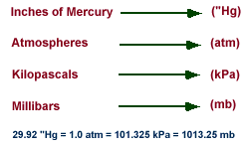
In aviation and television weather reports, pressure is given in inches of mercury ("Hg), while meteorologists use millibars (mb), the unit of pressure found on weather maps.

As an example, consider a "unit area" of 1 square inch. At sea level, the weight of the air above this unit area would (on average) weigh 14.7 pounds! That means pressure applied by this air on the unit area would be 14.7 pounds per square inch. Meteorologists use a metric unit for pressure called a millibar and the average pressure at sea level is 1013.25 millibars.

High & Low Pressure: Pressure Gradient Force

When marking high pressure the scientists use a blue H while for low pressure a red L is used. Generally in the northern hemisphere winds travel counter clockwise around a low and clockwise around a high. Air moves from high pressure to low pressure. Because of that fact scientists use something called a pressure gradient force. In the absence of other forces, air moves from high pressure to low pressure due to gradient force.

The influence of the Pressure Gradient Force (PGF)

Winds
H
High Pressure
L
Low Pressure
PGF

Isobar
996 mb
1000 mb

Isobars

To identify pressure on a weather map scientists use isobars. The pressure on an isobar is constant. Areas between isobars have pressure between the values of the isobars. Isobars usually change by 4 millibars. Isobars are similar to the lines on a topographical map.
Pressure Activity
scaffolding activity
Introduction: Though you may not realize it, the air has weight. All the air molecules in the atmosphere exert a force, or pressure, on our bodies. Atmospheric pressure is the force exerted by the weight of the air above an object or surface. Variations in pressure generate winds, which play a significant role in day to day weather conditions. The purpose of this activity is to introduce characteristics of pressure, high and low pressure centers, and a brief analysis of an idealized pressure field. Key words throughout this activity link directly to helper resources that provide useful information for answering the questions.

Characteristics of Pressure:
- What are the different units of pressure? Which unit is used most by meteorologists?
- Circle the correct response in the following sentence: Pressure (increases / decreases) with height. Please explain why pressure changes this way with height.

High and Low Pressure Centers:
- Identify the symbols that represent a high-pressure center on a weather map. Do the same for a low-pressure center.

- Pictured below are two imaginary columns of air molecules exerting pressure on the surfaces below them. The left column contains fewer air molecules than the right column.

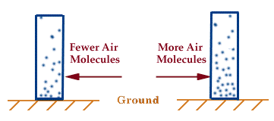

Which column is more representative of the atmosphere above a high-pressure center? Which one is more likely to be found over a low pressure? Using the correct symbols for labeling high and low pressure centers (see question #3), mark your answers beneath the appropriate columns in the diagram above.
Analysis of a Pressure Field:

- The diagram below is an idealized pressure field resembling those commonly found on surface weather maps. The numbers along each contour indicate the pressure value in millibars for that particular contour. Use the diagram below to answer the following questions.

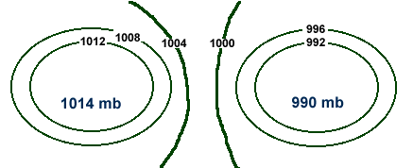
  - What is the name of the contour lines shown? What do they represent?
  - Label the diagram above to indicate the positions of the high and low-pressure centers. Please use the correct symbols (see question #3).

  - Draw an arrow (on the diagram above) to indicate the direction in which the pressure gradient force is pointing.

  - Draw arrows to show the direction that wind is circulating around the high and low.

Examine the Current Pressure Field:

- Using the Internet, view a current weather map. One can be created at the following Internet addresses:
  - http://covis.atmos.uiuc.edu/covis/visualizer/index.html
  - http://wxp.eas.purdue.edu/surface/index.htm
  - http://twister.sbs.ohio-state.edu/text/wximages/us/natmap.gif
  - http://taiga.geog.niu.edu/current/surface.gif
  - http://http.rap.ucar.edu/weather/surface.html

- Using what you learned in questions 1-5, use colored pencils to mark the positions of high and low pressure centers using the correct symbols on the weather map. Place the pressure gradient force lines between the highs and lows.

